**A TECHNICAL REPORT ON**

**STUDENT INDUSTRIAL WORK EXPERIENCE SCHEME (SIWES)**

**CARRIED OUT AT**

**SADIQ COMPUTER CENTER,**

**GANYE, ADAMAWA STATE**

**FROM: 4TH JANUARY, 2023**

**TO: 4TH MAY, 2023**

**BY**

**FAHAD HUDU**

**ST/CS/ND/21/145**

**SUBMITTED TO**

**THE DEPARTMENT OF COMPUTER SCIENCE**

**SCHOOL OF SCIENCE AND TECHNOLOGY**

**FEDERAL POLYTECHNIC MUBI**

**IN PARTIAL FULFILLMENT FOR THE AWARD OF NATIONAL DIPLOMA (ND) IN COMPUTER SCIENCE**

**JUNE, 2023**

**DEDICATION**

This report is dedicated to God almighty for his favor, mercy and grace open my life especially during my 4-month SIWES programmed I would also like to dedicate this to my parent and siblings for their love and support and everyone else that contributed towards making my training grate and successful one.

# ACKNOWLEDGMENTS

I thank God Almighty for making me to undergo students industrial work experience scheme (SIWES) successfully.

My gratitude goes to my parent for their prayers, financial and moral support during my attachment.

I also appreciate the kind gesture of my brothers and sisters and those who supports me in prayers and contribution during my industrial attachment.

I whole heartedly thank my Head of department Mallam Adamu Garba Mubi, SIWES coordinator and all lectures of Computer Science for their effort to ensure my success as their students.

I am greatly indebted to my co-SIWES students to mention, may God strengthen our relationship together and grant us academic excellence.

I sincerely thank you all for your contribution and support.

**ABSTRACT**

*The report summarises the result of work done during my SIWES experience, the technical report consists of four chapters, which comprises of introduction, history and criteria’s of SIWES in chapter one followed by their aims and objectives, historical background, organizational structure of the organization in chapter two, while chapter three consist of the work actually carried out during the SIWES programme and lastly chapter four consist of the summary, conclusions and recommendation.*

**Table of Contents**

**Title page - - - - - - - - - - i**

**Approval page - - - - - - - - ii**

**Dedication - - - - - - - - - - iii**

**Abstract - - - - - - - - - - iv**

**CHAPTER ONE**

1.0 Introduction - - - - - - - - - 1

1.1 Background of SIWES - - - - - - - 1

1.2 Brief History of SIWES - - - - - - - 1

1.3 Aims and Objectives of SIWES - - - - - - 2

**CHAPTER TWO**

2.1 Brief History of the Organization. - - - - - - 3

2.2 The Objective of the Organization. - - - - - - 3

2.3 Organizational Chart - - - - - - - - 3

**CHAPTER THREE**

## 3.1 Introduction Microsoft Word - - - - - - - 16

**CHAPTER FOUR**

4.1 Summary - - - - - - - - - 25

4.2 Conclusion - - - - - - - - - 25

4.3 Problems - - - - - - - - - 26

4.4 Recommendations - - - - - - - - 27

**CHAPTER ONE**

1. **INTRODUCTION**

The concept behind industrial training schemes is to acquire practical, knowledge in addition to what has been learn institution. The four months mandatory supervised industrial attachment is program instituted by the federal government to help student for their different field of studies.

* 1. **BACKGROUND OF SIWES**

It aims at exposing student to the practical and the actualization of work situation which they may meet after graduation and the learning is meanly expected to produce graduate qualification to meet man power of employments of (ITF), there was growing concern amount the industrialist that graduate of higher learning do not passes adequate background student for the opinion that theoretical education going higher institution was responsive enough to meet the need of employers of the labour as a requirement of national board for technical education (NBTE) polytechnic training before obtaining the National Diploma (ND).

Experience scheme (SIWES), is a National programme introduced by Government in 1974 for student in tertiary institution.

### **1.2 BRIEF HISTORY OF SIWES**

**SIWES** was established by **ITF** in 1973 to solve the problem of lack of adequate practical skills preparatory for employment in industries by Nigerian graduates of tertiary institutions.

The program “Student industrial work experience scheme” is a pure skill-acquisition program structured for the tertiary institutions as a complementary and enhancement program to the theoretical education, laboratory and workshop practices engaged in by student in different higher institutions. The SIWES was initiated to improve the student’s technical abilities (performance/knowledge) and expose them to industrial culture thereby preparing them to be acquainted with the roles to play towards the technological advancement of the nation.

It is there for a practical aspect of the academic works, which the students may not be opportune to carry out throughout their stay in the higher institutions. Based on this fact, the Federal Government decided to establish a body (regulatory) which engages in the training of the technical manpower. The body is named industrial Training Fund (ITF). The government also undertook to make up for the deficiencies by structuring and established Students Industrial Training (SIT) as it was then called but in 1973 the SIWES was formed which is the subsidiary.

### **1.3 AIMS AND OBJECTIVES OF SIWES**

1. One of the objectives of SIWES is to create an avenue for students to acquire industrial skills to complement their theoretical knowledge and improve their experiences in their course of study.
2. The program prepares the students for industrial working conditions prior to their graduation.
3. To enable the students to learn personal relationship with employers and co-employees on graduation.
4. It exposes the student to working methods and techniques in handling equipment and machinery.
5. It develops the student in make critical and realistic approaches to solving problem.
6. It serves as a way of improving the abilities of the students and to contribute to the growth of the nation.
7. It gives the students the opportunity to practice what they have been taught in various disciplines.
8. The SIWES program strengthens the employer’s involvement in preparing the students for employment.

**CHAPTER TWO**

**2.1 BRIEF HISTORY OF THE ORGANIZATION.**

Sadiq computer center is a school that trains student on computer fundamental studies with the view of self-sustenance. It helps student to accrued skillful method of computing.

Sadiq computer center offer practical knowledge of general computer application including Microsoft office suit which comprise of Microsoft office word, Microsoft Excel, Microsoft power point, Microsoft access database and a lot more, it also offer Diploma and certificate in course mentioned above.

**2.2 ORGANIZATIONAL CHART**

Figure 2.1: Organizational Chart

**CHAPTER THREE**

**3.1 INTRODUCTION TO MICROSOFT WORD**

Microsoft word is a word processing package was designed initially for document. Microsoft word (MS-Word) is an application package which designed and created to solve problem. Or Microsoft word is a word processing package designed to make work easy, Microsoft word is designed purposely for typing of document, report, memos, and letter etc.

**Types of document that can be processed include:**

1. Letter
2. Memo
3. Books
4. Magazine

It help us to create document that can be up load online

**3.1.1 USES OF MICROSOFT WORD.**

Microsoft word is referred to as word processing package. The Uses of Microsoft are:

1. Edit
2. Arrange
3. Types---etc.

**3.1.2 HOW TO LAUNCH MICROSOFT WORD.**

1. Click on start button on the task bar window 7)
2. Move the mouse pointer to programs or select all programs
3. Click on Microsoft word

OR

1. Double click on the desktop environment.
2. Then the Microsoft word will open

**3.1.3 HOW TO SAVE WORK IN MICROSOFT WORD (MS-WORD).**

1. Click on file
2. Select save as if you are saving the work for the first time
3. A dialog box will appear
4. Type the file name and click on save.

**3.1.4 HOW TO INSERT TABLE IN MS- WORD.**

1. Click on insert on the menu bar
2. Click on table
3. Click table
4. Click insert table on the drop down menu.
5. Select the number of Columns and Rows
6. Click ok

**3.1.5** **MICROSOFT WORD ENVIRONMENT.**

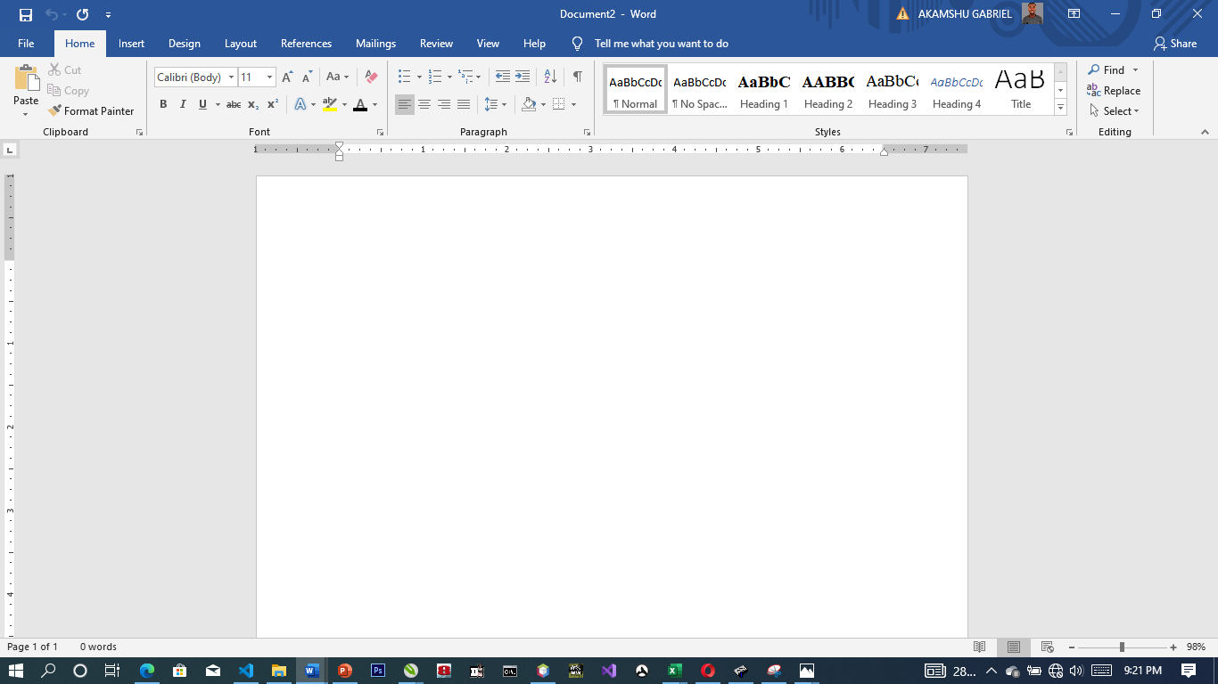

**Microsoft Word Viewed Screen.**

1. The title bar: wherever you saved any work, the file name and reside on the title bar
2. The menu bar: menu bar is made up of (file, edit, view, insert, format, tools, table, and window help).
3. The standard tool bar: consist of spelling and grammar icon, help.
4. The formatting tools bar: contain **(Bold (B), *(I), Italic* underline (U).**
5. **The drawing tools bar:** consist of any thin like auto shape, square, circle, text, word art pie chart, and bar chart etc.
6. **The insertion point:** or cursor is a place where you can insert table, row column etc.
7. **The ruler:** rule is mean for adjusting the MS-word environment etc.

**CONTROL SHORTCUT KEYS**

Ctrl + C: Copy selected text or object.

Ctrl + X: Cut selected text or object.

Ctrl + V: Paste copied or cut text or object.

Ctrl + A: Select all text in the document.

Ctrl + B: Bold selected text.

Ctrl + I: Italicize selected text.

Ctrl + U: Underline selected text.

Ctrl + Z: Undo the last action.

Ctrl + Y: Redo the last undone action.

Ctrl + F: Open the "Find and Replace" dialog box.

Ctrl + S: Save the current document.

Ctrl + P: Print the current document.

Ctrl + N: Create a new, blank document.

Ctrl + O: Open an existing document.

Ctrl + F1: Show or hide the Ribbon.

Ctrl + F4: Close the active window or document.

Ctrl + F5: Restore the size of the active window.

Ctrl + F6: Switch between open Word documents.

Ctrl + F9: Insert an empty field.

Ctrl + F12: Open the "Save As" dialog box.

**HOW TO LAMINATE A DOCUMENT**

1. Turn on the laminating machine and wait for it to warm up.
2. Place the document you want to laminate inside the laminating film.
3. Insert the laminating film into the laminating machine with the sealed end first.
4. Feed the laminating film through the laminating machine.
5. Allow the laminated document to cool before handling it.
6. Trim any excess laminating film material around the edges of the document with scissors or a paper cutter, if necessary.

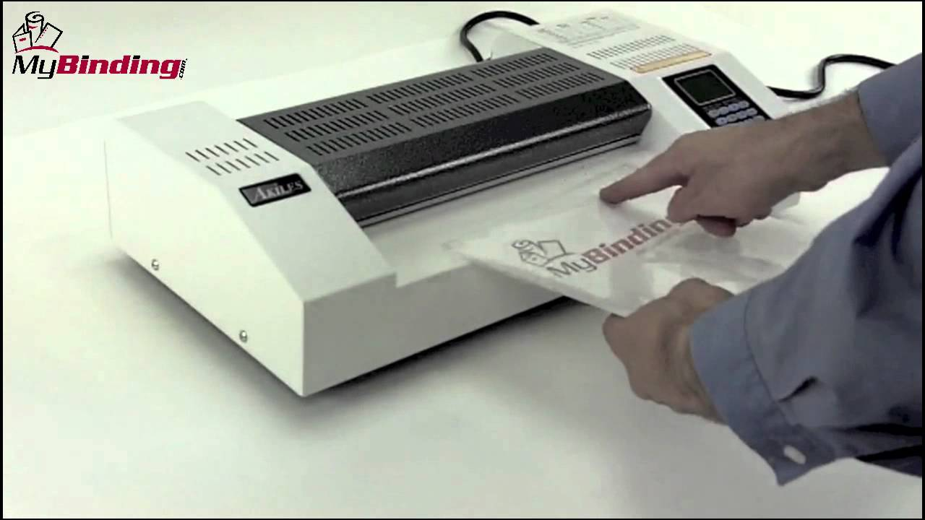

Figure 3.1: Laminating Machine

**HOW TO PRINT A DOCUMENT IN MICROSOFT WORD**

1. Select **File** > **Print**.
2. To preview each page, select the forward and backward arrows at the bottom of the page.

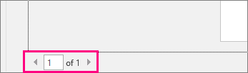

If the text is too small to read, use the zoom slider at the bottom of the page to enlarge it.

The zoom slider to enlarge or reduce the text is shown.

1. Choose the number of copies, and any other options you want, and select the **Print** button.

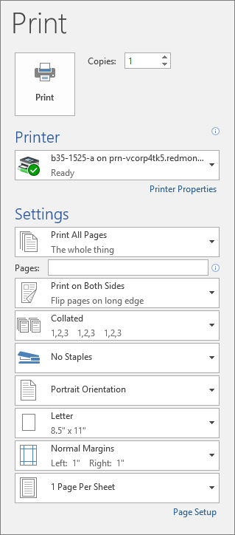

**TYPES OF KEYBOARD AND KEYBOARD LAYOUTS**

**QUERTY Layout**

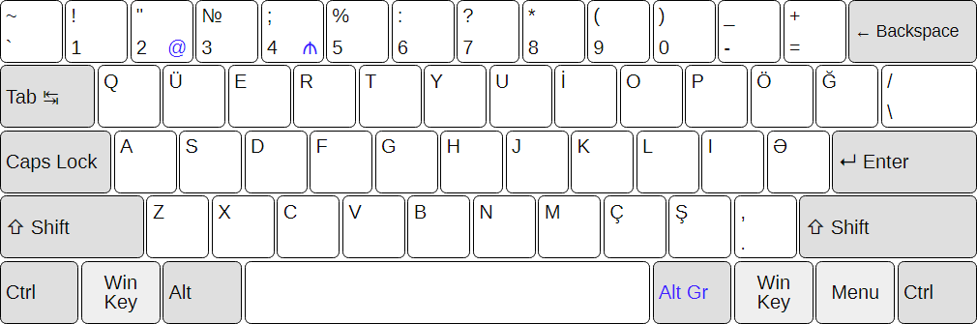

**QWERTZ Layout**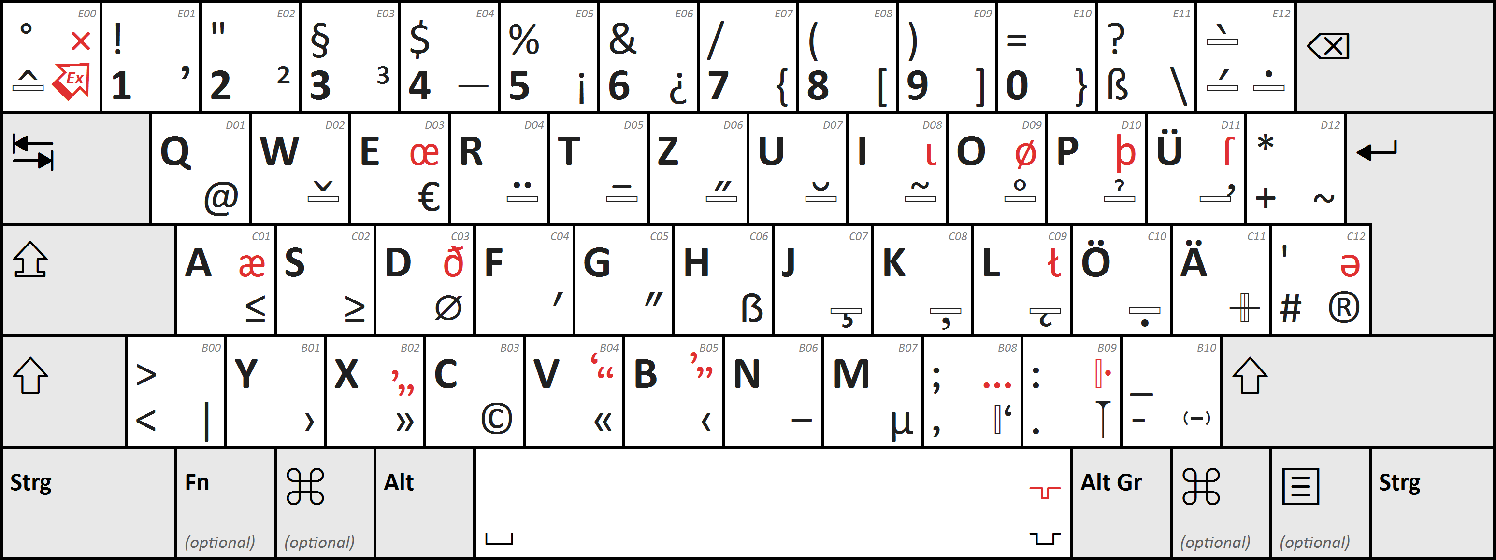

**AWERTY Layout** 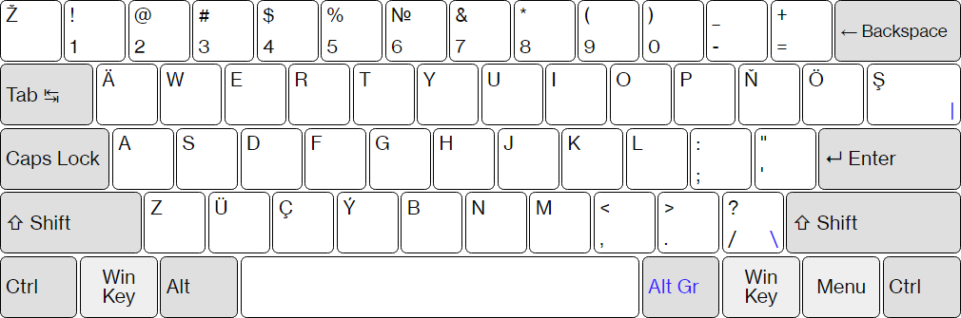

**CHAPTER FOUR**

**SUMMARY, CONCLUSION, PROBLEMS AND RECOMMENDATIONS**

# 4.1 SUMMARY

The relevance of the SIWES program cannot be over emphasized considering the fact that it has significantly reduced the gap between my theoretical and practical knowledge about computer hardware and software, installations, maintenance and networking. The processes of communication which include data and telecommunication the use of switch in the networking and what networking is all about.

The program is indeed a commendable one in that it affords students ample opportunities of being exposed to good working relationship with colleagues and the field experience with customers. This little exposure has widened my knowledge about my course of study, not only that it has automatically changed my views about lift in general. The firm at large has taught me how to be independent of my own how to be conscious of my health and safety at its peak relating to the environment where I carried out my SIWES program. It was indeed a highly rewarding experience to be with Excellence Computer Training Center, Yola, Adamawa State.

**4.2 CONCLUSION**

In conclusion, I thank ITF in general for their effort towards the Student Industrial Training Scheme. The contribution that the industrial training offered to student will not be over emphasized. It has exposed me seriously to a certain depth and length of practical capability on Computer Knowledge and practical Know how.

It has also acquainted me with the working condition, which I am expected to encounter in the near future. I will say that SIWES has a greater advantage on me, it has greatly exposed me to the practical application of all that I have been through in the school, SIWES is an experience that all student must pass through this is because it gives a full practical knowledge of what has been through in classroom.

Finally, I have a strong believe that this comprehensive based on the experience, I acquired during the industrial training scheme will convince every user training is not difficult.

I therefore strong conclude that the continuous existence of SIWES programme as it is very necessary since it plays a dominant role in the development of student of Computer Science in the acquisition of practical experience.

# 4.3 PROBLEMS OBSERVED DURING MY PROGRAM

1. The time frame set for the program is too short as some of the aspects of the program where not completed.
2. Lack of Financial support from the company to aid transportation to and from training.
3. Attentions are not given to the IT students by the workers it is learn if you want to learn or ask if you want to know.
4. Cost of Training: The Student has to be registered as a student of a particular organization in order to carry out the program.

**4.4 RECOMMENDATIONS**

Below are the recommendations that should be given serious consideration so as alleviate the suffering of students undergoing SIWES.

Firstly, the Federal Government of Nigerian should make a positive effort in reducing the overall cost of production so that companies should be producing to fill capacity and accommodate SIWES populaces. Also, certain monthly allowance may be given to the student by company accepted then (student to ease transportation problem).

Secondly, the Industrial Training Fund (ITF), should try and increase the money paid at the end of SIWES to the student so as to justify the Cost of Living we experienced.

Finally, the ITF official should please continue visiting the students, to ensure that what they are learning is in line with the ITF requirement.

**REFERENCES**

Edward, B. M.D (2003). The Effect of SIWES on a student, Federal Ministry of Works, Lagos. Nigeria.

Lowenthal, R. (2009).[*Improving the Design of PowerPoint Presentations*](http://www.ucdenver.edu/academics/CUOnline/FacultySupport/Handbook/Documents/Chapter_12.pdf). University of Colorado Denver.